For Whom the Bill Tolls:

A Simulated Annealing Model of Draft Legislation in the US Congress

WORKING PAPER

NAMES

:

I. Introduction

The dynamics of policy-making in Congress have been extensively studied. Numerous formal and empirical models of various aspects of the institution have been developed and tested, including: voting decisions (Mayhew 1974, Kingdon 1989), Congressional ideology (Poole and Rosenthal 1997), party influence in Congress (Cox and McCubbins 1993, 2005, Aldrich 1995) or lack thereof (Krehbiel 1993, 1998) and committee dynamics (Shepsle and Weingast 1981, Gilligan and Krehbiel 1989). However, in spite of this wealth of literature, there remains surprisingly little research on the precise dynamics of policy formation. Existing models tend to reason backwards from votes, constructing measures of ideology from grouped voting decisions and assuming that legislators devise legislation that falls in line with their past voting patterns.

In this paper, we attempt to complement these studies by developing a model of policy development through draft legislation. We model the development of legislation as a sequential bargaining process among sub-groups within the Congress. An initial round of informal consideration among colleagues forms the basis of a formally introduced bill. We envision this section of the model as a search for cosponsors. In the process of building a base of support for a bill it is altered as cosponsors ‘sign-on’ and add information (and preferences) to the legislation. We model this process as a simulated annealing algorithm, representing legislation and preferences a bit strings. After the initial round of annealing generates an outcome (‘draft legislation’), a second round of annealing (‘committee consideration’) ensues. Finally, our simulated Congress votes on the issue.

Taking this approach to the policy-making process captures several crucial features of Congress that are often neglected. First, we model Congress as a networked body and treat bill-drafting as an essentially social process. Legislators seek out support from among their companions, selected primarily by homophily. Second, we explicitly model the role of draft legislation and informal policy-making groups in Congress. This form of policy-making has been more prominent in recent years, with various ‘gangs’ of legislators emerging to formulate draft solutions to the 2012-2013 budget crisis. Few of these groups had any formal authority to address the problem - they were merely interested individuals coming together to form policy (and merging their networks towards the goal of policy success).

Congressmen face many competing considerations in their role as legislators. They must balance their constituents against interest groups and struggle to form make correct policy choices in the face of broad uncertainty. This paper addresses the role of networks and draft bills in combating this uncertainty and creating viable legislation.

II. Networks and Policy Choice in Congress

Building support for legislation is not an easy task. Legislators face a large body of colleagues with heterogeneous preferences. They also face serious consequences if they fail too publically – as ThomasMann once observed, Congressmen feel ‘unsafe at any [electoral] margin’ (Mann 1978). Moreover, social choice problems (e.g. Arrow 1956, McKelvey 1976, Shepsle and Weingast 1979) severely complicate the emergence of any stable policy outcome. The structure of Congress is designed, in part, to mitigate these challenges (Weingast 1981, for example).

There is a rich literature on agenda control devoted primarily to explaining how politics and power color the outcomes of legislative choice. Agenda control arguments run through committees, although researchers differ on how committees are formed and influenced. Partisan policy-making theories emphasize ‘negative agenda control’ over the legislative process: by dominating committees, parties prevent legislation they do not support from reaching the floor (Cox and McCubbins 1993, 2005). Parties also wield ‘positive agenda control’, the ability to push favored bills through the legislative process (Rohde 1991, Aldrich 1995). On the other hand, Krehbiel (1993, 1998) argues that committees are ultimately controlled by individual legislator preferences, and specifically the median member of the chamber in question (following the classic median voter theorem; Black 1958). While these theories have their differences, they share a keen awareness of the importance of institutional roles and powers in the legislature. The implication of both theories is that policy ought to change substantially as it moves through the legislative process – if committees act as gatekeepers, whether on behalf of their own particularistic interests, the House floor, or party leadership, they should possess the power to shift policy in the direction they desire.

Both theories also suggest the importance of building support for legislation *prior to formal consideration*. Without some level of initial backing, either from party elites or an adequate subset of legislators on the floor, policy is highly likely to die in committee. Legislative productivity data reveals this trend clearly: Table 2.1 charts the percentage of bills introduced that actually received a floor-vote.

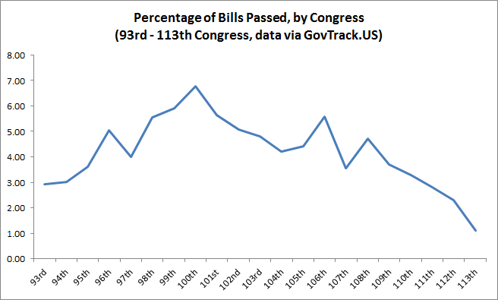

The vast majority of legislation goes to committee to die. A random piece of legislation, without co-sponsors or other forms of support, is unlikely to be an exception.The nature of the policy-process also suggests a strong value to establishing support for legislation early: given the power of entrenched forces (whether acting on behalf of party or preferences) at each step of a bill’s progression through Congress a sponsor must carefully marshal a supporting coalition or risk his interests being completely overwhelmed by others.

How do legislatorsbuild an initial base of support for policy? Existing research suggests several mechanisms. First, legislators might discuss their ideas with others informally, or circulate draft legislation to other members as a means of ‘feeling out’ support for a particular policy. This is a good method of obtaining co-sponsor support as well – rather than introduce legislation and wait for others to read it, members are likely to seek out potential backers. There is limited existing research on draft circulation. Nourse and Schacter assess the draft process from a judicial law perspective, noting that drafts are generated primarily by staffers, lobbyists and professional drafters, based on input from legislators (typically in the form of broad summary documents; Nourse and Schacter 2002). This is broadly consistent with research on lobbying strategies: rather than attempt to persuade their enemies, lobbyists function as informational resources for their allies (Hall and Wayman 1990, Hojnacki and Kimball 1998). One of their informational roles is to generate draft legislation and policy ideas.These theories suggest that specific pieces of draft legislation will appeal to certain subsets of legislators. If legislators are hearing similar things from their resources they are likely to develop similar policy ideas and support similar legislation.

Network ties between legislators may also contribute to the development of policy. Existing literature on co-sponsorship networks suggests that ties between legislators might serve as a powerful means of predicting vote outcomes. Several studies (e.g. Zhang, Friend, Traud, Porter, Fowler and Mucha 2008)use network data to assess political polarization: findings are consistent with more conventional studies of Congressional ideology (e.g. Poole and Rosenthal 1997), indicating that polarization has increased over time, especially in the US House of Representatives. Tam Cho and Fowler find that Congress follows the pattern of a ‘small-world network’ (Grannovetter 1978). Their research indicates that weak-ties enhance the likelihood of final passage for important legislation (Tam Cho and Fowler 2010). Bratton and Rouse conduct a similar analysis of US state legislatures and attempt to evaluate the variables that influence tie-formation. They find that co-sponsorship activity is predicted by ideology, district-proximity, demographic homophily and network transitivity (Bratton and Rouse 2011). This research explains the findings of network measures of polarization: ideology influences tie-formation, which in turn leads to the development of ideologically stratified networks.

Analysis of networks in Congress reveals that co-sponsorship ties act as powerful predictors of coalition formation in the legislature. This in turn suggests that the careful cultivation of network ties is a path to power in Congress. We argue that legislators cultivate co-sponsorship relationships, in part, through interactions revolving around draft legislation.

III. A Simulated Annealing Model of Informal Policy-Making

This paper considers the role of informal deliberations in forming policy solutions – we develop a theory of policy-making oriented around draft-legislation and pre-legislative coalition building.Circulating draft legislation functions as a mechanism to build initial support for legislation in order to raise the odds of a bill’s success. Furthermore, the dynamics of policy agendas suggest that legislators face a constrained set of problems. The objective of forming solutions through informal coalition building is to control the solution environment, developing a piece of legislation that addresses the relevant problem while also allowing other legislators to take advantage of the opportunity by adding their own solutions and issues of interest.

The original bill sponsor, a legislator who has decided to attempt to make policy, is faced with a choice: should he distribute his policy proposal widely and attempt to solicit broad support? Or, should he keep distribution relatively restricted, retaining more certainty over content? We assume that once a policy is released it is largely removed from the sponsor’s hands. Admittedly, this is not literally true: a sponsor can always withdraw legislation. However, we believe it is effectively true – even if a sponsor withdraws from legislation in response to substantial changes made by others, the other legislators may easily re-introduce new, equivalent legislation. In other words, the sponsor’s primary role is to introduce a policy issue into the legislative arena and to propose a solution – the outcome of his action is left in the hands of his colleagues.

There are recent examples of this form of informal, sub-group policy-making. Consider the various informal ‘gangs’ of legislators that coalesced around competing solutions to the 2012-2013 budgetary crises (e.g. the ‘Gang of 6’). These groups represent initial sub-sets of legislators considering draft legislation – in most cases they had no formal authority beyond some degree of respect from their peers. Ultimately, their proposed solution failed to become policy. This outcome was seen as a failure of bipartisanship and moderate politics – our theory views it, in contrast, as a failure to understand the dynamics of informal policy-making. The ‘Gang of 6’ was too small to make an impact – while negotiation is easier among small groups, there is simply no guarantee that agreement among a small subset of a legislative body will translate into support within the entire body.

III. A. Model Overview

In this section, we present a model of informal policy formation based on simulated annealing. Conceptually, a bill is sponsored and considered by a network of legislators. This initial, informal group of policy-makers develops the framework of legislation through a round of annealing and builds some support for passage. Their work is then referred to a committee of interested members, who are allowed to alter the legislation through an additional round of annealing. This second alteration is analogous to committee agenda-setting powers (Cox and McCubbins 1993, 2004).

Each realization of the simulation is initialized with a new group of legislators. These legislators have a list of priorities and positions associated with a list of issues. Legislator priorities and positions may or may not conform to an ideological party agenda, depending on model parameters. Finally, a social network connecting the legislators is generated, using both homophily (McPherson 2001, Bratton and Rouse 2011) and preferential attachment (Barabasi and Albert 1999).

As the simulation runs, bills are sequentially processed as follows:

1. Proposal:
   1. A random legislator is chosen to sponsor a bill.
   2. The sponsor proposes a draft bill on any issue that has not already been addressed by law.
2. Draft circulation among cosponsors:
   1. All legislators connected to the sponsor in the social network are selected as cosponsors.
   2. The cosponsors revise the draft using simulated annealing; new issues may be added to the bill during the revision process and solutions on existing issues may change.
3. Committee review:
   1. The draft is referred to a committee; committees are chosen according to legislators for whom the main issue of the bill is a high priority.
   2. The committee revises the bill by simulated annealing; again, new issues may be added and existing solutions changed as a result.
4. Floor vote:
   1. The bill is referred to the floor for a vote.
   2. If the bill passes by simple majority (> 50% votes), the bill is made into law; i.e., the solutions addressed by the bill are recorded and the issues may not be revisited for the remainder of the realization.

This process is repeated for 200 proposals (or halts if all issues are passed into law).

The model is implemented in Python with object-oriented programming. There are three high-level classes that interact in the model: *State, Legislator,* and *Bill*. These are further described in separate sections below.

The fixed and free parameters of the model are listed and described in Table 5.1.

|  |  |  |
| --- | --- | --- |
| Table 5.1: Fixed and Free Parameters | | |
| Parameter | Description | Value [Variation] |
| Num_of_Representatives | Size of the legislative body. | 100 |
| Num_of_Issues | Size of the problem set. | 75 |
| Solution_Bit_Length | Bit string length of positions and solutions. | 4 |
| Committees_Per_Legislator | Legislator committee membership; lowest priority issue legislator serves on committee for. | 4 |
| Satisfaction_Threshold | Minimum satisfaction a legislator must have with a bill to support it. A calibrated value but after calibration was fixed for experiment variations. | 0.675 |
| Friend_Threshold | Minimum homophily (range [-1,1]) for legislators to be considered for preferential attachment. | 0 |
| Minimum_Friends | The number of links added as each legislator is added to the network. | 5 |
| Unaffilitated_Fraction | Fraction of the legislative population with no ideological party affiliation. | [0.05, 0.5, 1.0] |
| Green_Fraction | Fraction of the party-affiliated population belonging to the “Green” party. Remainder belong to the “Yellow” party. | [0.5, 0.75, 1.0] |
| Ideology_Issues | Ideological platform issues for the parties. | [0, 5] |
| State_Priorities | High-priority issues for all legislators. | [0, 5] |

III. B. Implementation Details

**Concept –**

* **Condense discussion of implementation by making it more linear – e.g. when implementing the model, this happens, then this happens, etc.**
* **Remove all but most necessary tables**

The implementation of the model proceeds in several major steps **(pictured in figure X.X).** First, the model environment (‘state’) is initialized, establishing core parameter values. Second, legislators are generated within the model environment, drawing on key environmental variables. Third, a network is generated among legislators, mapping them to friends within the environment. Finally, a bill-proposal structure is developed – this compromises the main interaction-loops of the model. We discuss each of these steps briefly.

**Figure of model implementation? Just to help orient people…**

1. Initialize Model Environment (‘state’)

The first procedure launched in the model is the environment itself (the ‘state’ object). This object serves as the foundation for the subsequent generation of interacting components. The state defines a set of possible priorities for legislators, defines ‘party-platform’ issues, and establishes the associated priorities and positions. The environment creates ‘legislator’ agents, who are assigned a party affiliation and provided with a seeded priorities list and a set of issue positions. These seeds serve as the foundation for a later stochastic process of finalizing legislators preferences on issues.

2. Having established the environment, the model next generates legislator positions and priorities. These are generated and assigned to legislators as follows. Starting with element 0 in this priority issues list and proceeding to the end of the list (element N-1, where N = nparty + nstate), a priority 2*(i + 1) is initially assigned to that issue. Thus, the lowest priority issue will be assigned an initial priority of 2, and the highest priority issue will be assigned an initial value of 2*N. All remaining issues (*Num_of_Issues* – N) are assigned an initial priority of 1.

Over *Num_of_Issues*2 iterations, issues are incremented, with the issue to be incremented at each iteration chosen at random according to the probability density of priorities in that iteration. Finally, priorities are normalized to the range [0,1]. This preferential attachment method generates a power law distribution of priorities, so that a legislator places very high priority on a small number of issues but low priority on most issues. The use of the seeded priority issues list means that legislators have some correlation in priorities to the extent that their seed priorities are the same, but heterogeneity is introduced with stochasticism.

The end-result of this process is a set of legislator agency with unique policy preferences. These policy preferences are conditioned by party priorities and the seed-variable established by the model environment in Step 1. This procedure contributes to the realism of the model environment – Congressmen all have particular issues that they care deeply about (that they prioritize much more highly). We believe a power-law distribution of issue priority strength is an accurate representation of this fact.

The final component of preference generation involves an assumption – in the case of a party-agenda issue (randomly assigned in Step 1), the legislator adopts the position of his party. In essence, we assume that several core issues represent powerful, crystalizing factors that differentiate our simulated parties. While there is obviously more inter-party heterogeneity than this approach captures, we consider it a justifiable assumption for the purposes of this paper. An explicit model of individual legislator preferences is a task for future research. Moreover, existing research indicates that legislator preferences generally reduce to a single dimension in the case of floor votes (Poole and Rosenthal 1997). For all other issues, positions are assigned randomly from the range [0, 2*Solution_Bit_Length*-1], inclusive (i.e., a random bit string of a predefined length, set to the variable ‘solution_bit_length’).

3. Network Generation

Having generated an environment and a population of legislator agents with unique characteristics, we complete the model universe by generating a social network among legislators. This network is designed to capture the social dynamics of legislating – a Congressmen will naturally have a set of friends and close colleagues that he interacts with more than others. Further, Congressmen are likely to

**……**

**TRANSITION AND DISCUSS NETWORK GENERATION**

**Network generation**

Drawing on legislators positions and priorities, we generate a social network using ‘preferential-attachment’ and homophily. The network generation follows the procedure in **FIGURE X.X.**

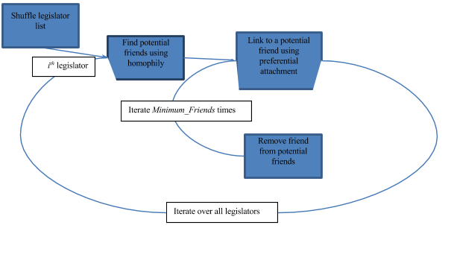

Homophily (similarity between two legislators) is the inverse of distance, which is calculated as follows. The distance between two strings is defined as the increasing depth on a binary tree, where the most significant bit (MSB) of the two bit strings is worth 50% similarity, the next MSB is an additional 25 similarity, etc. Two identical strings result in 100% similarity, whereas strings that have only the MSB in common are only 50% similar. At position *i* in the bit strings, a bit’s difference in the binary value results in an additional (½)i+1 reduction in similarity. For an infinitely long bit string length, similarity in all positions but the MSB would result in a 50% similarity as well; practically speaking, however, since our model only uses a bit string length of 4, the maximum achievable *dis*similarity is 93.75%.

This method was used to enable strong issue position correlation between party-affiliated legislators while still allowing for some heterogeneity among their positions. However, this feature was not used in this model (party platform positions are homogeneous among affiliated members) and could be an extension in future work.

Another benefit to this method, however, is that on any given issue, it generates a bimodal (rather than uniform) distribution of all legislator positions. In a completely uncorrelated population (i.e., all independents), a uniform significance of bits towards homophily created an extremely low likelihood of any two legislators having sufficient agreement over the entire solution space to meet any reasonable assumption of friendship threshold. The decreasing significance of the binary tree method is more reasonable in that it could be said to model any two legislators agreeing on the generalities of a solution to an issue (say “for” or “against”) while perhaps differing on implementation details. From a model implementation perspective, it makes the network generation much more tractable using reasonable assumptions of friendship threshold.

A legislator’s *potential friends* are defined as the set of legislator agents who have a minimum similarity of a pre-set ‘friend-threshold’ total homophily on all issues with the legislator. Similarity is a sum of homophilies on positions of all issues, weighted by and normalized to the legislator’s priorities on those issues. Homophily on an issue is the unary inverse (*1 – x)* of the distance between legislators positions and priorities.

Edge assignment is as described in Barabasi and Albert (1999): each time an edge is added, a pdf is generated from the degree distribution in the sub-network of *potential friends*, and a target node for the edge is selected randomly from that pdf.

The typical outcome of this procedure is a ‘small-world’ network among legislator agents, consistent with existing research on social networks in Congress **(EG THAT PAPER I CITE EARLIER).**

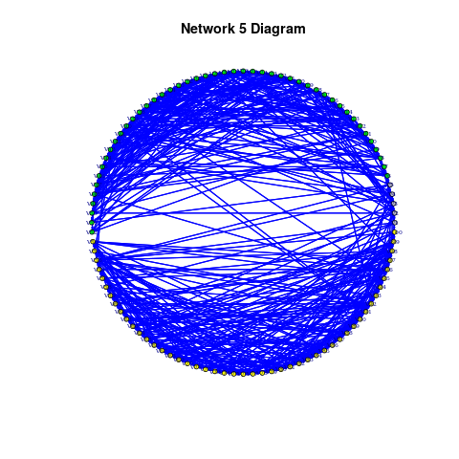

4. Bill Proposals

Having defined a population of legislators and their relationship to each-other, we next establish a procedure for legislators to engage in the business of law-making.[1] In our model, a sponsor **is randomly selected {I think this is how it works}** to propose a piece of legislation. This legislation addresses a particular issue and he naturally sets his proposed solution to the issue at his preferred solution (his issue position). This process is analogous to ideal-point analysis in the Congress literature in political science (e.g. Krehbiel 1998, Huber and Shipan 2002).

We innovate by going beyond basic proposals and counter-proposals. Once a sponsor develops a bill, he first initiates a search-process for co-sponsors, with the objective of building an initial base of support for his policy. This search phase coincides with a round of simulated annealing (discussed in the next section). In brief, the bill is revised as co-sponsors join on – the sponsor gains support by sacrificing the purity of his positions (or, alternatively, by adding additional issues and positions to the legislation, ‘bundling’).

5. Simulated Annealing

The simulated annealer implements the Metropolis algorithm for simulated annealing (Metropolis 1954, Kirkpatrick et al. 1983): a state with lower energy than the current state is accepted, while a state with higher energy is accepted with **probability $P(state) = e^{-ΔE/kT}$.** The annealer iterates over the temperatures provided to it in the annealing schedule, and for each temperature, iterates the corresponding number of times provided to it. Each iteration, the modifier function is called on the current state, and the modified state’s energy is calculated per the objective function; the modified state’s energy is then accepted or rejected. The final state returned by the algorithm is the lowest energy (highest satisfaction) one encountered.

For our model, k was set to $k = -0.1/ln(1/2)$. This means that, at a temperature of 1.0, a decrease of 0.1 in satisfaction is accepted with probability ½. The time at temperature annealing schedule was configured linearly.

III.C. Model Verification, Validation, and Calibration

The model was verified through code review and incremental testing: subunits of functionality were tested by verifying expected intermediate outputs, before implementing more complex functionality.

As an exploratory model, little effort was made to validate outputs. Where applicable, assumptions have been stated and are validated against either literature or reasonable expectation. For example, we cap the maximum number of committees a legislator agent may serve on by an approximation of the actual limitation imposed on real-world Congressmen.

Similarly, we calibrate legislators’ ‘satisfaction thresholds’ (the point at which they agree with legislation) to a level that generates a ‘pass-rate’ of approximate 4%. This is comparable to passage rates in the actual US Congress, which have varied between 2% and 7% in recent history.[2]

IV. Experimentation, Results and Analysis

A suite of experiments were run against all combinations of parameter values identified in Table 2. An exception was any variation in *Green_Fraction* when *Unaffiliated_Fraction* was 1.0, which would have been duplicative results since party affiliation is moot in that case; a separate experiment was run to obtain results with *Unaffiliated_Fraction* = 1.0 and variations over *Ideology_Issues* and *State_Priorities*. To obtain statistically significant results, 30 realizations were simulated for each parameter combination.

Tables 5.9 and 5.10 identify the metrics that were calculated or recorded for each proposal during individual run histories and for final aggregate outputs after a completed simulation, respectively. To keep the data set manageable, run histories were not recorded for the main suite of experiments. Instead, histories were only recorded for the baseline model: *Unaffiliated_Fraction=0.05, Green_Fraction=0.5, Ideology_Issues = 10.*

|  |  |
| --- | --- |
| Output | Description/Notes |
| Proposals | In rare instances, the legislative body passed laws on all issues in the problem space before the simulation run time. This metric allowed capture of those instances. |
| laws count | How many bills were passed into law. |
| Provisions | How many issues were passed into law. |
| total satisfaction | Final legislative body satisfaction with all legislation. |
| total change | average change in the main issues’ positions from proposal to law |
| total votes | How many votes were cast ‘aye’ over the simulation run. |

**Table 5.10 - Aggregate metrics recorded for each simulation realization**

We describe three sets of results before discussing their possible meanings and implications: the networks, session histories and aggregated experiment results. The experiment results command the bulk of our attention below, whereas the network analysis and session histories support explanation and validation of the model description, above.

The experiment profile included 720 runs with party affiliations and another 120 without parties, making 840 individual session histories, each with up to 200 proposals. Our analysis focuses on the aggregates of model parameters but describe here the results within each individual session. For example, an individual legislative session typically considers 200 bills based on one of 75 issues. Some issues are the main purpose behind one or more bills, but not an equal number of times; many only once.

Figure 2 provides a summary of one sample session history. We identify issues numerically, 1-75 along the bottom axis and show the number of votes for the bill based on that issue along the *y* axis. The issues are sorted left-to-right by the median number of votes they received in the session. The statistics for vote counts are further described by the box plots. Mean votes are shown with a red dot and the standard error with a red line. Issues that underlie a single bill are flat---a single black line and a red dot.

Some attributes of this plot deserve attention. Notice that the number of votes an issue receives is not determined by the number of times it is considered and that the mean and median values are often very different. This can be explained by the path-dependent structure of the model, as bills based on a particular issue are not always proposed by the same congress member and by extension may be modified by a different local network or committee before going to the floor for vote.

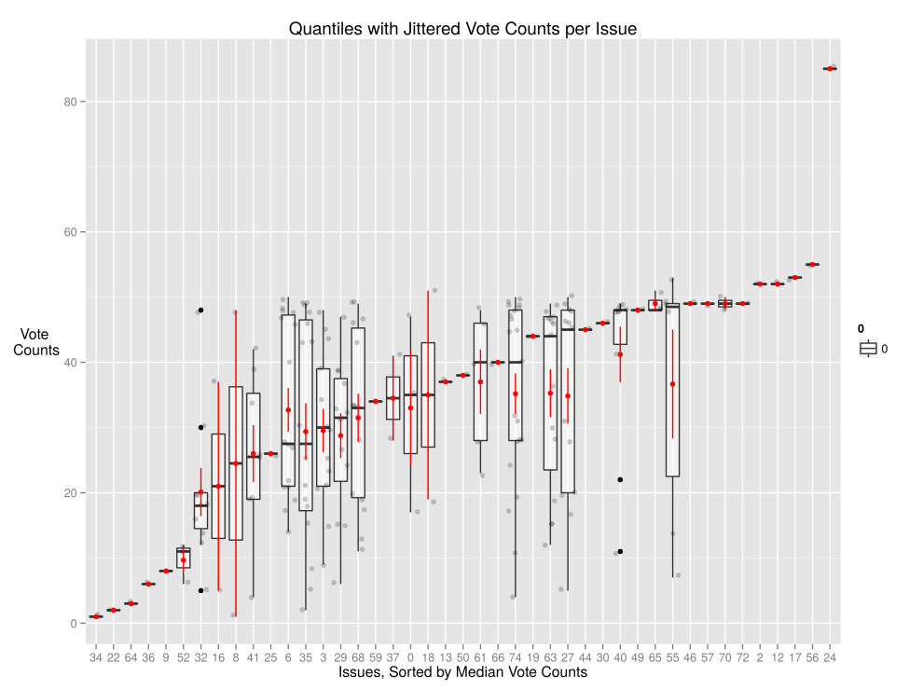

**Figure 6.1 - Summary of proposals, aggregated by issue identifier for an individual session history.**

Individual session histories vary, even with the same experiment parameters. This is because each legislative session generates a unique network of ties between congress members. The shape of the congressional networks are based on experiment parameters. The network diagram below is typical of networks with a small number of unaffiliated members (5%) and roughly equal number of Yellow and Green party members. Because the model generates network ties based on ideological homophily, the circular layout highlights a general division between Green (top half) and Yellow (bottom half) parties, with unaffiliated members (in grey, left side) more highly-connected to both Yellow and Green members. Networks with no party affiliation are more uniform, as are networks with a super-majority.

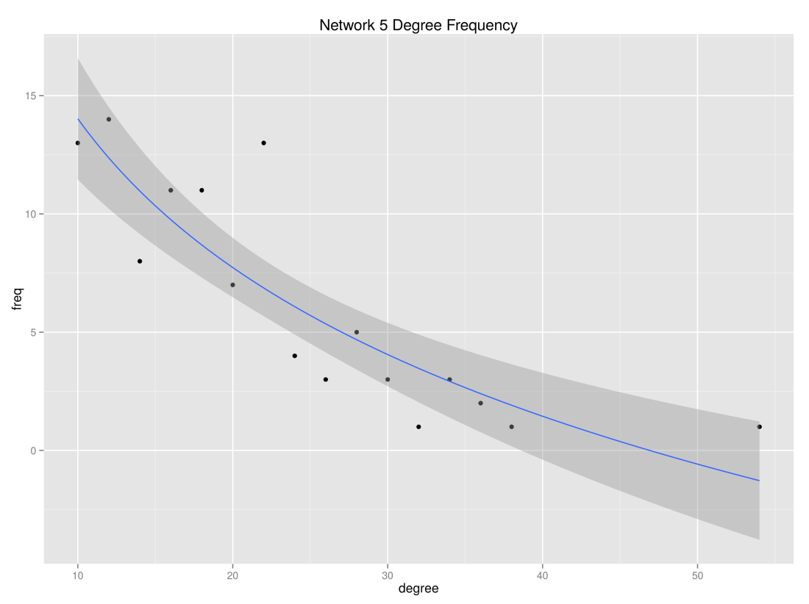

**Figure 6.3 - Frequency of sample network degrees with *log(x)* fitness line. Shaded area represents standard error.**

We can verify that the model network (at least in with these parameters) can be described as a small world network by calculating some measures of small-worldness. We use the qgraph implementation (Epskamp, *et al* 2012) of Humphries's methods (Humphries 2008) on our sample network and show them in Table 11, below. Using Humphries's small-worldness metric as the primary parameter, a network with a value *> 1* can be considered a small world network, though a value *> 3* would be definitive. Having global values for network transitivity and average path length higher than for a high number of random sub-networks is another indicator of small-worldness, according to Humphries (*ibid*). Our sample network is more typical of real-world networks in the U.S. Congress than the networks we generate with a large super-majority (75% or 100% membership of affiliated members in one party) or those experiments without any party affiliation. Existing research finds that Congressional co-sponsorship networks exhibit the characteristics of small world networks.

|  |  |
| --- | --- |
| Metric | Sample Network |
| "small-worldness" metric | 1.41070182 |
| global transitivity | 0.17755857 |
| mean transitivity from 300 random sub-nets | 0.11282573 |
| lower quantile transitivity, 300 random sub-nets | 0.09678792 |
| upper quantile transitivity, 300 random sub-nets | 0.12978730 |
| average shortest path | 2.52565657 |
| average shortest path, 300 random sub-nets | 2.26399798 |
| low quantile shortest path, 300 random sub-nets | 2.24493232 |
| upper quantile shortest path, 300 random nets | 2.28454646 |

**Table 6.1 - Measures of "small-worldness" with qgraph for the sample network (Epskamp 2012).**

The parameters reflected the sample legislative session history and the sample network are characterizations of typical, observed legislatures. However, a key goal of our experiments was to test the relevance of these characteristics on organizational performance. For example, Figure 5 (below) shows the number of new laws passed in each of the 30 iterations across the parameter space. Notice that in 11 of the 24 experiment jobs in the parameter space, the median number of new laws approved by the congress is zero.

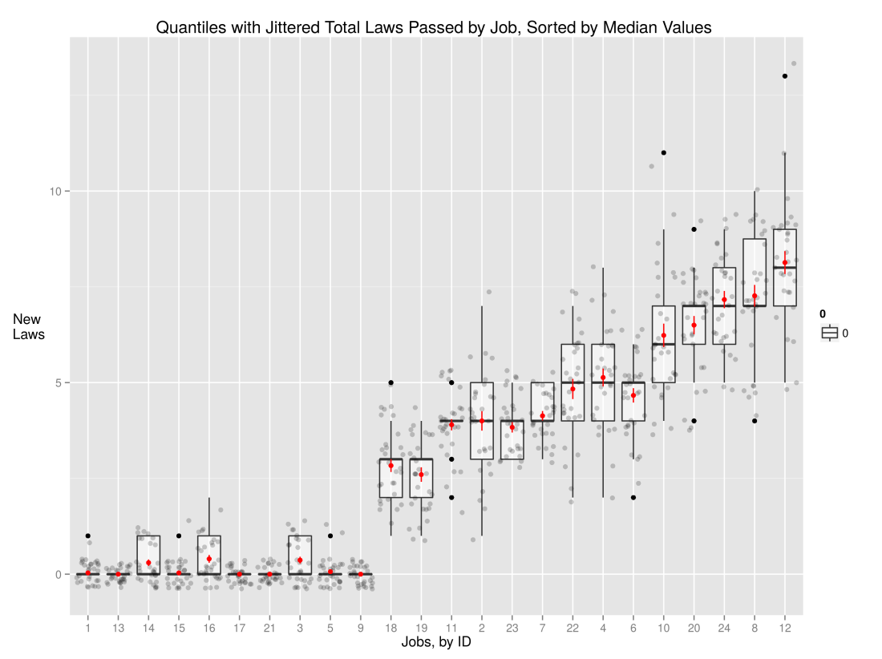

**Figure 6.4 - Some parameters produce no or few new laws in most legislative sessions---typically, when there are no externally-defined priorities.**

We expected that having some key, national issues (state issues) and having some issues aligned with a particular ideology (ideology issues) could influence the productivity (number of laws passed) by each legislative session. Our results show that these parameters were not deterministic, except for a condition where there were no state priority issues and no ideology issues; in those cases there were typically few or no laws passed. To be more specific, state priority issues and party ideology issues are defined external to the agents. See figure 6.5 for a view that categorizes jobs by those with or without state priorities (top facet) and with or without ideology-related issue priorities. Ideology-based issue priorities generated more new laws on average than state priority-based issues. Where there are common priorities among members, more bills garner enough support to become laws.

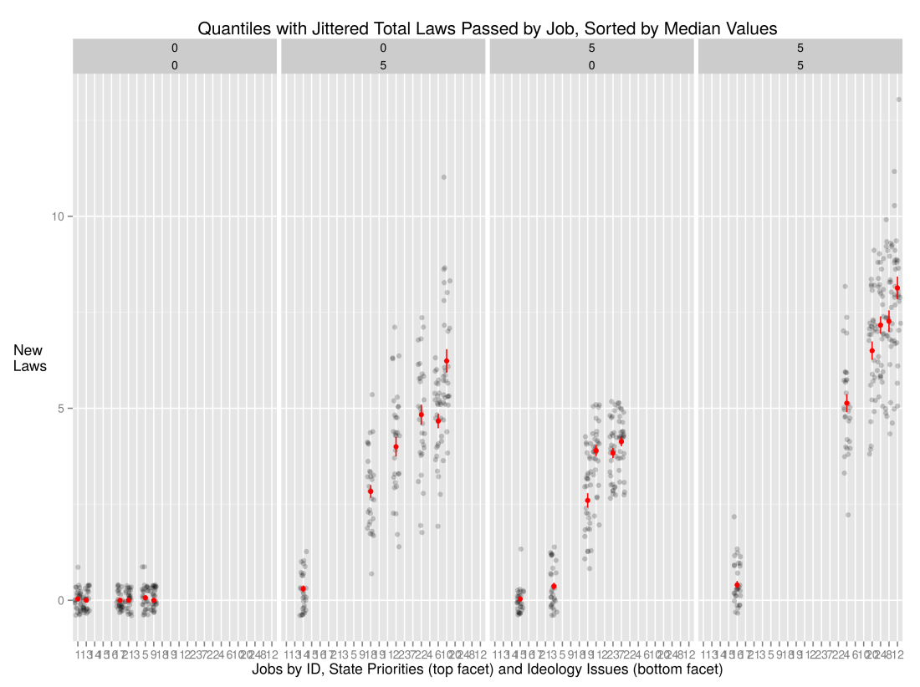

**Figure 6.5 - Model runs with no ideology issues and no state priorities consistently produce no new laws, but other structural conditions may also produce no laws.**

The analysis from this point forward excludes the eleven cases where no laws were typically passed, which means that there are no cases in which there are neither state priority issues nor ideology issues. In these remaining thirteen cases only two represent cases with a small unaffiliated community and a legislature equally divided between the two parties. While the other cases may be interesting, they did not produce sufficient data for analysis.

In the remaining cases we observe a significant difference in the dynamic in the number of new laws, the aggregate number of votes and in the overall satisfaction of the legislatures from modifying bills with additional issues. Notice three primary characteristics of the cases portrayed in Figures 6.7, 6.7 and 6.8 (below). First, the number of provisions required to garner votes may spread across the entire *x* axis, be all on the left side or all on the right. Secondly, the magnitude of the period representing the difference in number of laws passed within a particular case is consistently similar across the cases; regardless of other parameters. Finally, the number of laws passed when there is no super-majority is positively correlated with the addition of issues to improve the fit of a particular bill to the reviewers, committee and the floor. In other words, when there is a super-majority (at 75% or 100% of affiliated members), appeasement decreases the chances that a bill will pass the floor vote.

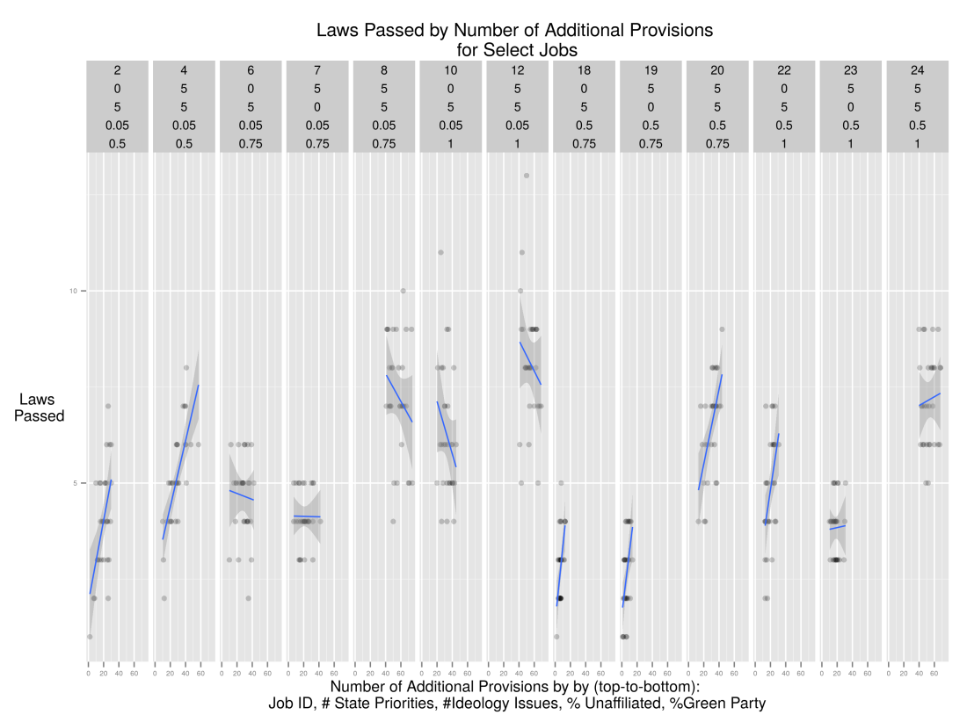

**Figure 6.6 - Of those parameters that (usually) produce new laws, the number of laws passed with additional issues may be either positively or negatively correlated, depending on whether the super-majority is partisan or unaffiliated.**

The phenomena associated with the number of laws that get passed is reflected also in the number of votes bills receive at the floor, though the correlation is not identical. For example, notice the case on the far right side---the case represented by job 24---the number of laws passed is positively correlated with additional issues, whereas the total number of votes is negatively correlated with additional issues.

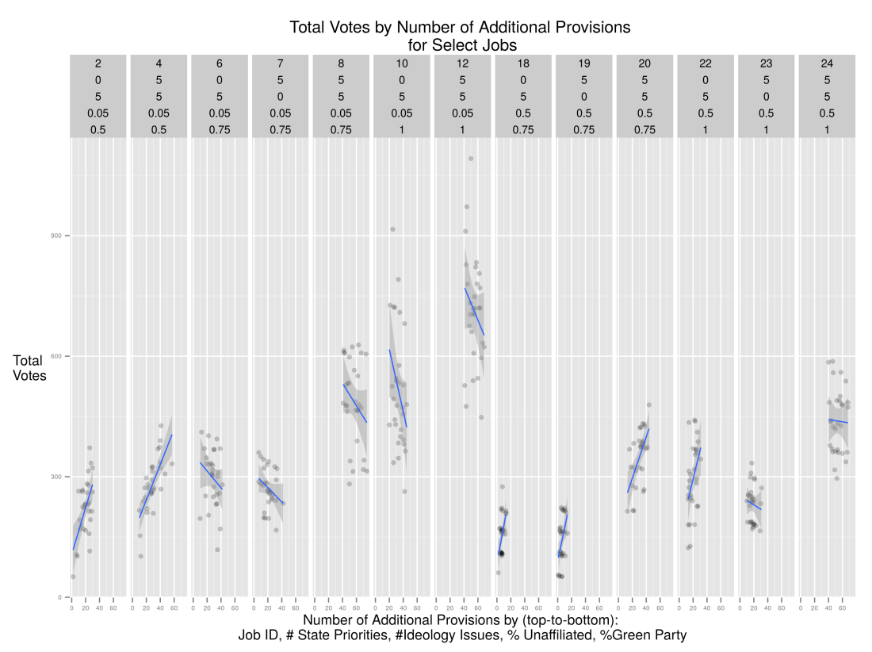

**Figure 6.7 - Of model parameters that (usually) garner votes, party-affiliation plays a similar role as for number of laws passed as bills are augmented with additional issues.**

The final plot shows a radical departure from the trend with the number of new laws and the total number of votes for an issue. In all cases, except that depicted in job 2, adding issues to improve fit decreases overall satisfaction with the bill. Even in this case with a small unaffiliated community and a balanced legislature, the correlation looks tenuous. If we discount the two lowest values for satisfaction, the correlation will likely tilt to a negative slope.

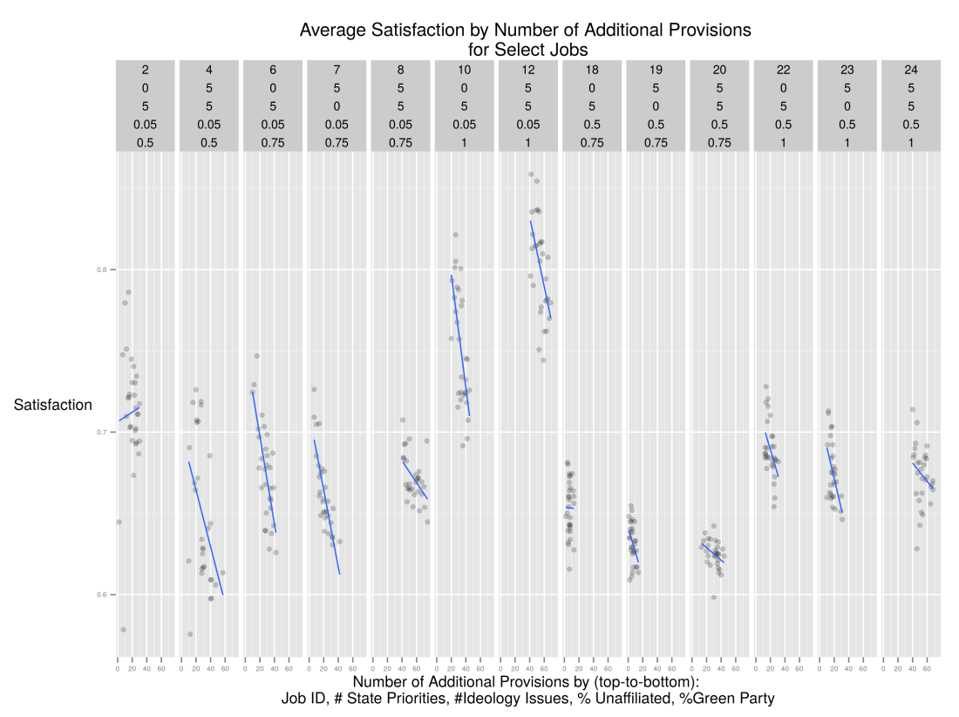

**Figure 6.8 - The correlation of overall satisfaction of bills as new issues are added is consistent neither with number of laws passed nor with votes garnered, but still may align with presence of a super-majority.**

**VII. Conclusion and Future Work**

This paper has presented a simulated annealing model of policy-formation in Congress. Our results indicate that, as more issues are added to a bill, overall legislator satisfaction decreases, regardless of the party structure in a congress. Adding issues to appease a minority garners fewer votes and decreases productivity. Finally, some structures are not likely to produce legislation, regardless of other factors involved.

Future research might look more carefully at finding a tipping point at which the correlation switches from positive to negative or the extent to which a lack of party affiliation changes productivity (number of new laws) or efficiency (number of additional issues required to garner a vote). It may be worthwhile to collect network metrics for each legislative session and test for correlation between these deeper network characteristics and productivity and efficiency. Finally, we could extend the model to examine the chances of a bill being passed, depending on which fraction of the membership proposes it---might a bill have better chances of succeeding if a member has a co-sponsor from another party propose the legislation.

**References**

Adler, Scott, and Wilkerson, John, 2012, *Congress and the Politics of Problem Solving,* Cambridge University Press

Aldrich, John, 1995, *Why Parties?* University of Chicago Press

Baumgartner, Frank and Bryan Jones, 1993, *Agendas and Instability in American Politics*, University of Chicago Press

Bratton, Kathleen and Rouse, Stella, 2011, “Networks in the Legislative Arena: How Group Dynamics Affect Co-Sponsorship,” *Legislative Studies Quarterly*, Vol. 36, No. 3

Butts, Carter T., Mark S. Handcock, and David R. Hunter. (2014). network: Classes for Relational Data. R package version 1.9.0. Irvine, CA. <http://statnet.org/>.

Butts, Carter T. (2008). ``network: a Package for Managing Relational Data in R.'' Journal of Statistical Software, 24(2).

Cain, Bruce, Ferejohn, John, and Fiorina, Morris, 1987, *The Personal Vote*

Cox, Gary W. and McCubbins, Mathew, 1993, *Legislative Leviathan: Party Government in the House*, University of California Press

Cox, Gary and McCubbins, Matthew, 2005, *Setting the Agenda*, Cambridge University Press

Csardi G, Nepusz T: The igraph software package for complex network research, InterJournal, Complex Systems 1695. 2006. <http://igraph.org>

Denzau, Arthur, Riker, William and Shepsle, Kenneth, 1985, “Farquharson and Fenno: Sophisticated Voting and Home Style,” *The American Political Science Review*, Vol. 79, No. 4

Epskamp, Sacha and Angelique O. J. Cramer, Lourens J. Waldorp, Verena D. Schmittmann, Denny Borsboom (2012). qgraph: Network Visualizations of Relationships in Psychometric Data. Journal of Statistical Software, 48(4), 1-18. URL <http://www.jstatsoft.org/v48/i04/>.

Ferejohn, John, 1986, “Logrolling in an Institutional Context: A Case Study of Food Stamp Legislation,” in Congress and Policy Change, Gerald C. Wright, Jr., Leroy N. Rieselbach, and Lawrence C. Dodd, eds. New York: Agathon Press, Inc.

Fowler, James, 2006, “Connecting the Congress: A Study of Co-Sponsorship Networks,” *Political Analysis,* Vol. 14, No. 4

Gilligan, Thomas and Krehbiel, Keith, 1989, “Asymmetric Information and Legislative Rules with a Heterogeneous Committee,” *American Journal of Political Science*, Vol. 33, No. 2

Gilligan, Thomas and Krehbiel, Keith, 1990, “Organization of Informative Committees by a Rational Legislature,” *American Journal of Political Science*, Vol. 34, No. 2

Grannovetter 1978

Hall, Richard and Wayman, Frank, 1990, “Buying Time: Moneyed Interests and the Mobilization of Bias in Congressional Committees,” *The American Political Science Review*, Vol. 84, No. 3

Handcock M, Hunter D, Butts C, Goodreau S, Krivitsky P and Morris M (2014). _ergm: Fit, Simulate and Diagnose Exponential-Family Models for Networks_. The Statnet Project (<http://www.statnet.org>). R package version 3.1.2, [http://CRAN.R-project.org/package=ergm](http://cran.r-project.org/package=ergm).

Heclo, Hugh, 1978, “Issue Networks and the Executive Establishment: Government Growth in an Age of Improvement,” in *The New American Political System,* Anthony King (ed), American Enterprise Institute

Hojnacki, Marie and Kimball, David, 1998, “Organized Interests and the Decision of Who to Lobby in Congress,” *The American Political Science Review*, Vol. 92, No. 4

Humphries, M. D., & Gurney, K. (2008). Network "small-world-ness": a quantitative method for determining canonical network equivalence. PLoS One, 3(4), e0002051.

Hunter DR, Handcock MS, Butts CT, Goodreau SM, Morris and Martina (2008). “ergm: A Package to Fit, Simulate and Diagnose Exponential-Family  
Models for Networks.” _Journal of Statistical Software_, *24*(3), pp. 1-29.

Jacobson, Gary, 1989, “Strategic Politicians and the Dynamics of U.S. House Elections, 1946-1986,” *American Political Science Review*, Vol. 83, No. 3

Jacobson, Gary, 1990, “The Effects of Campaign Spending in House Elections: New Evidence for Old Arguments,” *American Journal of Political Science*, Vol. 34, No. 2

Jacobson, Gary, 2012, *The Politics of Congressional Elections,* Longman Press

Jenkins, Jeffery, and Munger, Michael, 2003, “Investigating the Incidence of Killer Amendments in Congress,” *Journal of Politics*, Vol. 65, No. 2

Kingdon, John, 1989, *Congressmen’s Voting Decisions*, University of Michigan Press

Kingdon, John, 1995, *Agendas, Alternatives and Public Policies,* HarperCollins

Kirkpatrick, S., Gelatt, C., Vecchi, M. P. ,1983, "Optimization by Simulated Annealing," *Science* 220

Krehbiel, Keith, 1991, *Information and Legislative Organization*, University of Michigan Press

Krehbiel, Keith, 1998, *Pivotal Politics: A Theory of U.S. Lawmaking*, Chicago University Press

Mann, Thomas, 1978, *Unsafe at Any Margin: Interpreting Congressional Elections*

Mayhew, David, 1974, *Congress: The Electoral Connection*, Yale University Press

McPherson, Miller, Smith-Lovin, Lynn, Cool, James, 2001, “Birds of a Feather: Homophily in Social Networks,” *Annual Review of Sociology*, Vol. 27

Metropolis, N., Rosenbluth, A.W., Rosenbluth, M.N., Teller, A.H., 1953, "Equations of State Calculations by Fast Computing Machines," *Journal of Chemical Physics,* Vol. 21, No. 6

Newman, M. E. J. (2003). The structure and function of complex networks*. SIAM Review, 45(3), 167–256.

Nourse, Victoria and Schacter, Jane, 2002, “The Politics of Legislative Drafting – A Congressional Case Study,” *New York University Law Review*, Vol. 77

Polsby, Nelson, 1968, “The Institutionalization of the US House of Representatives,” *American Political Science Review,* Vol. 62, No. 1

Poole, Keith and Rosenthal, Howard, 1997, *Congress: A Political-Economic History of Roll Call Voting,* Oxford University Press

Porter, Mason, Peter J. Mucha, M. E. J. Newman, Casey M. Warmbrand, 2005, “A network analysis of committees in the U.S. House of Representatives,” *Proceedings of the National Academy of Sciences of the United States,* Vol. 120, No. 20

Rhode, David, 1991, *Parties and Leaders in the Post-Reform House*, Chicago University Press

Sarkar, Deepayan (2008) Lattice: Multivariate Data Visualization with R. Springer, New York. ISBN 978-0-387-75968-5

Shepsle, Kenneth and Weingast, Barry, 1987, “The Institutional Foundations of Committee Power,” The *American Political Science Review*, Vol. 81, No. 1

Talbert, Jeff and Potoskia, Matthew 2002, “Setting the Legislative Agenda: The Dimensional Structure of Bill Cosponsoring and Floor Voting,” *The Journal of Politics*, Vol. 64

Tam-Cho, Wendy and Fowler, James, 2010, “Legislative Success in a Small World: Social Network Analysis and the Dynamics of Congressional Legislation,” *The Journal of Politics*, Vol. 72, No. 1

Tullock, Gordon, 1967, "The Welfare Costs of Tariffs, Monopolies, and Theft," *Western Economic Journal*, Vol. 5, No. 3

Victor, Jennifer and Range, Nils, 2007, “The Social Utility of Informal Institutions: Caucuses as Networks in the 110th U.S. House of Representatives,” *American Politics Research*, Vol. 37, No. 5

Wickham, Hadley (2007). Reshaping Data with the reshape Package. Journal of Statistical Software, 21(12), 1-20. URL <http://www.jstatsoft.org/v21/i12/>.

Wickham, H. (2009). ggplot2: elegant graphics for data analysis. Springer New York.

Wickham, Hadley (2011). The Split-Apply-Combine Strategy for Data Analysis. Journal of Statistical Software, 40(1), 1-29. URL <http://www.jstatsoft.org/v40/i01/>.

Zhang, Yan, A.J. Friend, Amanda L. Traud, Mason A. Porter, James H. Fowler, Peter J. Mucha, 2008, “Community structure in Congressional co-sponsorship networks,” *Physica A: Statistical Mechanics and its Applications*, Vol. 387, No. 7

1. One might argue that this is a departure from realism, as the current Congress does not appear to do this. However, we are attempting to generate a broadly generalizable model of policy-making in legislatures. Some legislatures do legislature, periodically.
2. Pass rates are equal to the total number of bills passed in a given Congress divided by the total counts of introduced legislation for that Congress. Other metrics of legislative productivity as a proportion of items considered generate similar results. Data to calculate pass rates was collected from *Civic Impulse LLC* (http://www.govtrack.us).